This report:

% MINI: (Type-subtype and calculation errors %

checkReport3("http://accounting.auditchain.finance/reporting-scheme/mini/testing1/instance.xml",

['http://accounting.auditchain.finance/reporting-scheme/mini/type-subtype2/type-subtype2.xsd'], [cacheValidity(3600)],Result).

<http://accounting.auditchain.finance/reporting-scheme/mini/testing1/instance.xml>

<https://pacioli.auditchain.finance/reportAnalysis/e84feba105e9864e867f0655e8b48770f48353e3.report/index.html>

I switched some relations around to cause an error.

**Inventory** is defined in the base XBRL taxonomy to be part of **Current Assets**; **Property, Plant, and Equipment** is defined to be PART OF **Noncurrent Assets**:

<http://accounting.auditchain.finance/reporting-scheme/mini/type-subtype2/type-subtype2.xsd>

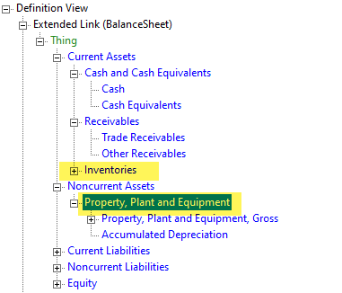

Nothing surprising, this is what one would expect.

But then I SWAPPED those two report elements in the report.

<http://accounting.auditchain.finance/reporting-scheme/mini/testing1/report.xsd>

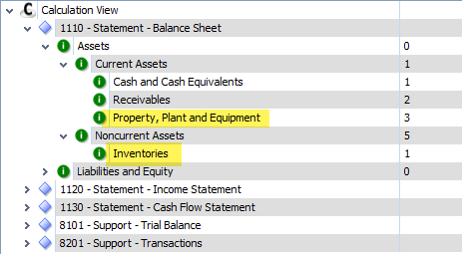

When I verify the report, I get the expected type-subtype errors:

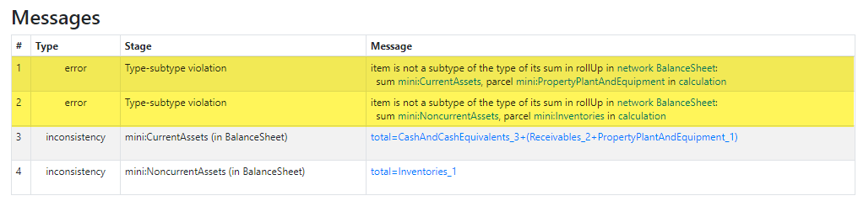

And of course there are calculation inconsistencies also because the values of the facts where not changed.

